**LGD**

**URL: https://lgdirectory.gov.in/**

* **Requirement:-**

Home (police) department wants to configure the Mike permission services having below process flow.

* **Process Flow:-**

**Citizen 🡪 subdivision (SDPO) 🡪 police station (Officer in charge) 🡪 subdivision (SDO) 🡪 permission certificate to Citizen**

* **Configuration:-**

Following are the work to be done in LGD before starting service configuration.

1. **Creating a new department(Home(Police))**
2. **Defining all police station administrative unit entity**
3. **Mapping the police station to Parent Subdivision – Set Parent Org Unit**
4. **Adding new Designation – Manage Designation Master**
5. **Generating Script – Updating the mapped date on server.**

**Functionality 1**: To create a new department if that department is not already defined in LGD.

* **Step 1:-**

Select **Department** 🡪 and click on **Create Department (State).**

* **Step 2:-**

We have created a new **Home (Police)** department as shown in below screenshot and click **save** button.

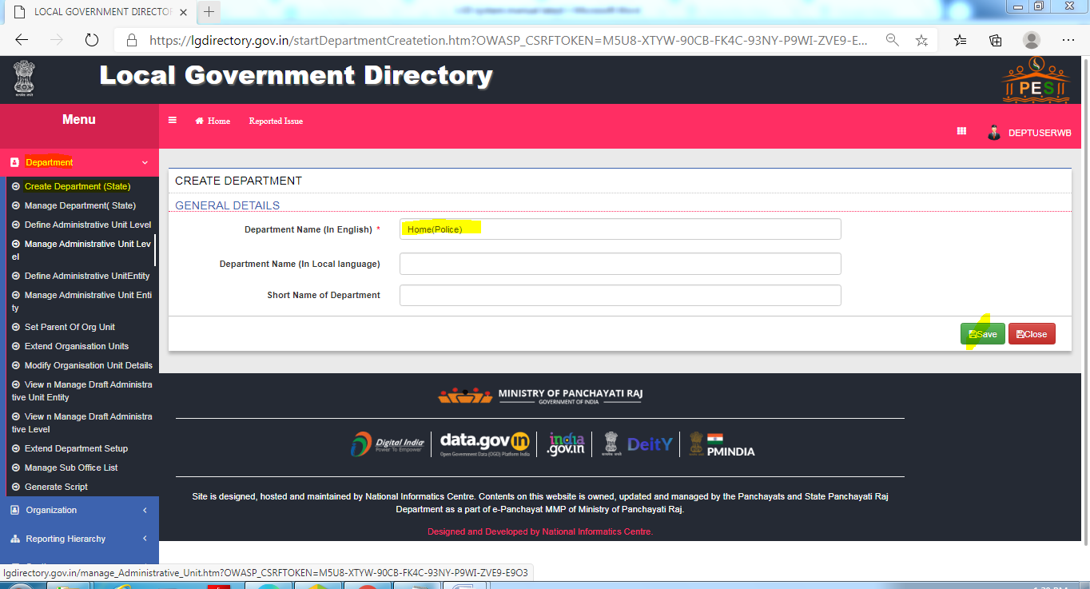

**Functionality 2:-** Defining Police Station name through **“Define administrative unit entity”.**

* **Step 1:**

Go to **Department** 🡪 and click on **Define Administrative Unit Entity.**

* **Step 2:**

Select Type of **Administrative unit Level** to 🡪 **Police Station**

Now Select **Parent Level Administrative Unit Entity** to 🡪 **Domkal**

And Fill **Administrative Unit Entity Name** to **🡪 Domkal PS**

* **Step 3:**

Select **Define the coverage of the Administrative Unit Entity** to 🡪 **No** and Click on **Publish** button.

**Below are the process to define a new police station (Domkal PS) which comes under sub division Domkal.**

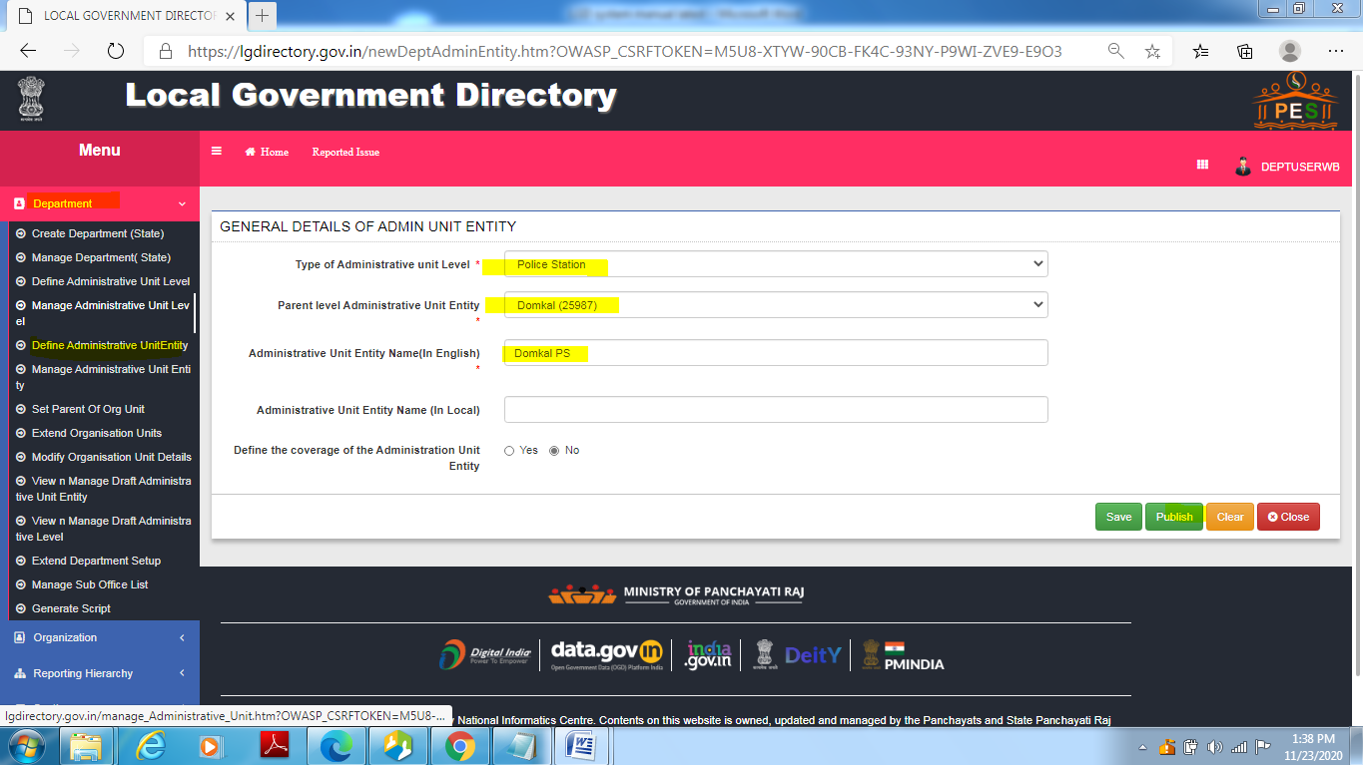

**Functionality 3:-** Mapping the Police Station to parent sub division using **“Set parent org Unit”** option

After defining all the police station as shown in **Functionality 2**, we have to map hierarchy of the police station to respective parent sub division.

* **Step 1:**

Go to **Department** 🡪 and click on **Set Parent of Org Unit.**

* **Step 2:**

Select Organization Type to **Department**

And Organization to 🡪 **Home (Police)**

Now Select **Level of Organization** 🡪 **Sub Division Level Organization**

And Select **Organization Unit** to 🡪 **Sub Division Police Office (Sub Division Domkal)** or respective Subdivision police office.

Click on button **Get all child Organization Units** to get its child Police Station Office.

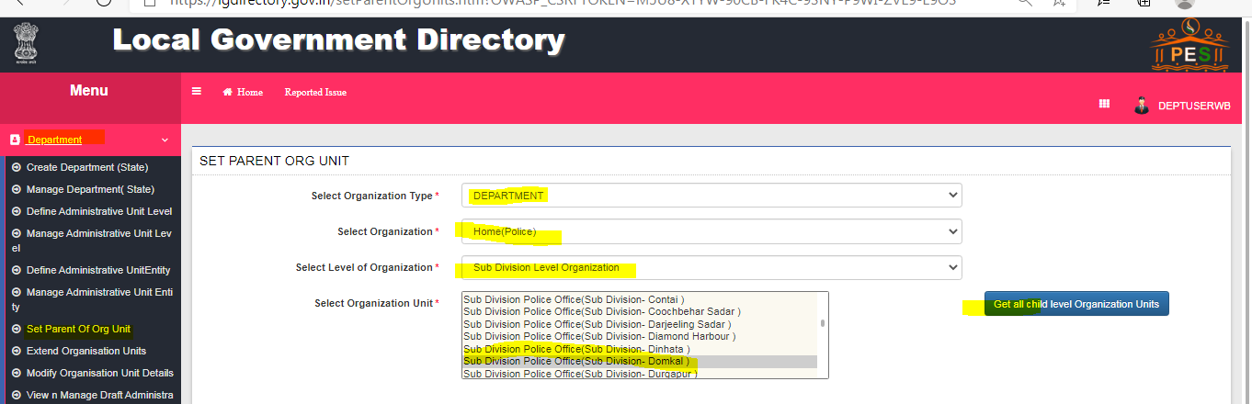

* **Step 3**

Select the appropriate Police Station for respective Sub Divisional Office and click the **“>”** button to be the selected one.

Here “**Police Station (Police Station - Domkal)”** is been selected**.**

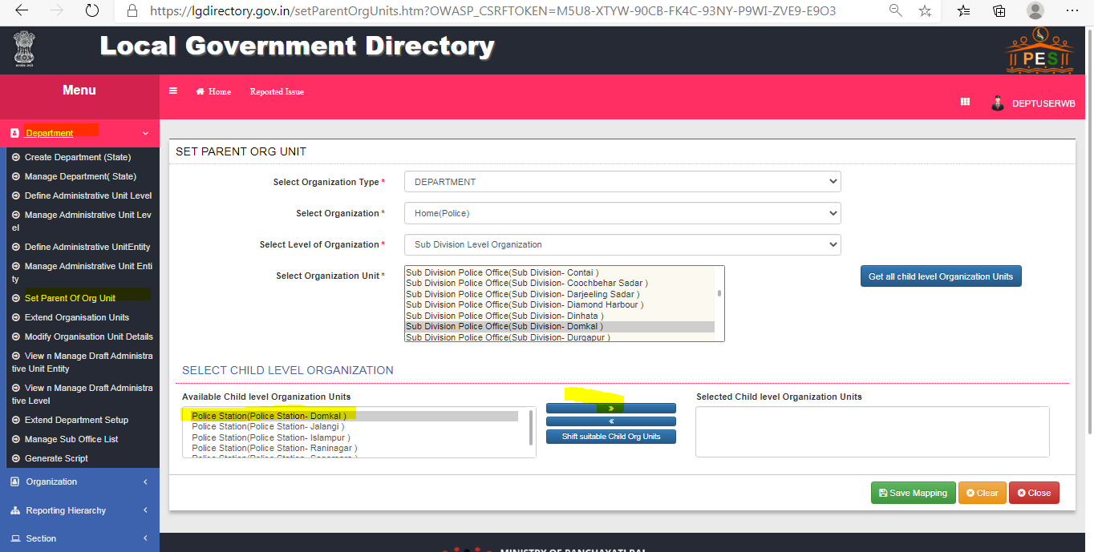

* **Step 4**

Now after selection of **child organization units** clickon **Save Mapping** button**.**

Here Police Station is mapped to respective hierarchical parent Sub Division.

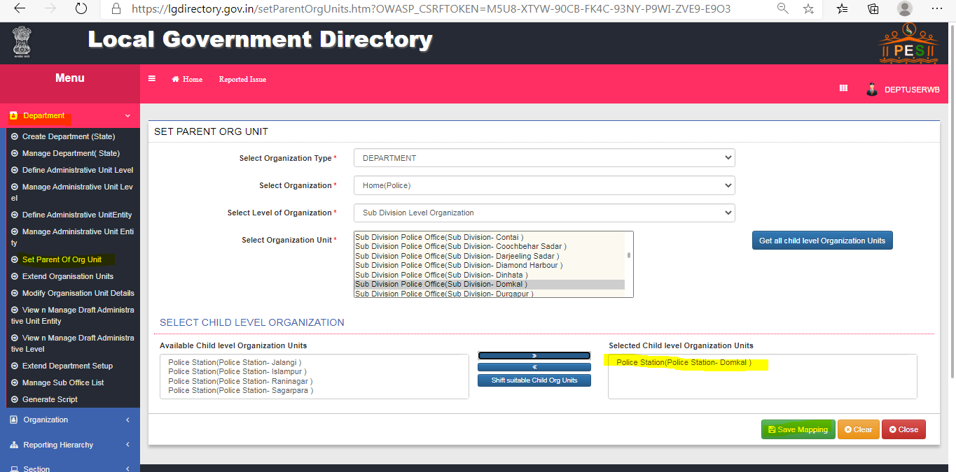

**Functionality 4:** Adding new designation like **“Officer in charge”** at police station through **“manage Designation Master”** option.

Below are the steps to add a new designation **“Officer in charge “at** police station level.

* **Step 1.**

Select 🡪 **Reporting Hierarchy**

And click on **Manage Designation Master (State).**

* **Step 2.**

Select from the **List of Organization Type** 🡪 **Department**

And **list of Organization** to 🡪 **Home (Police).**

And click on **Get Data.**

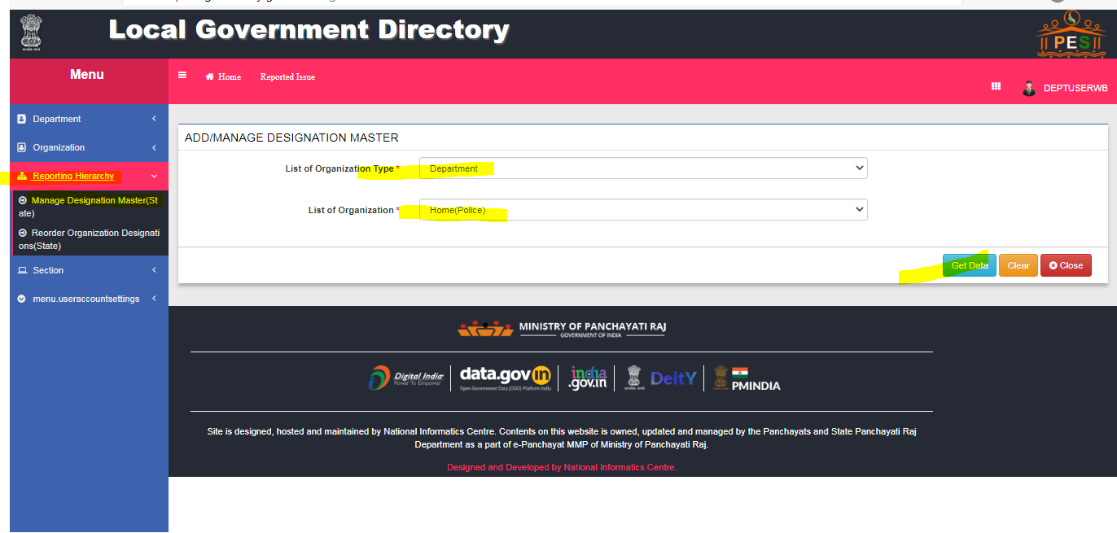

* **Step 3:**

Here **New Designation** could be added by clicking on **“+”** button.

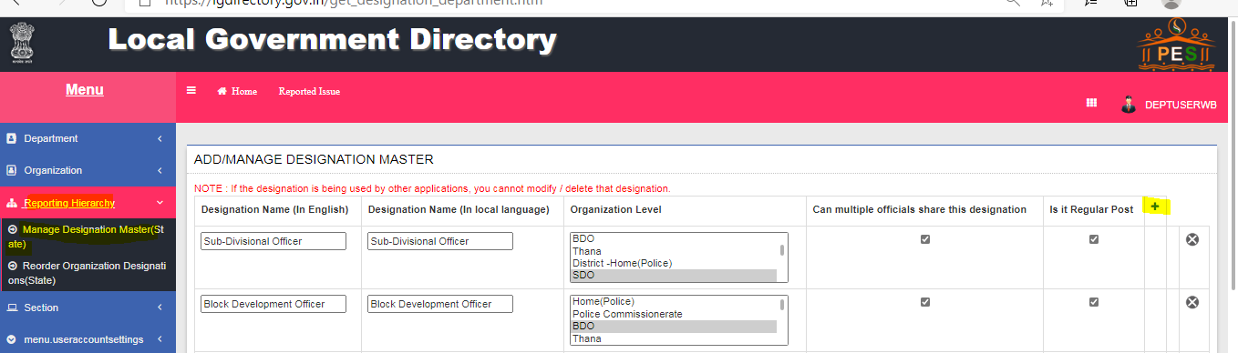

* **Step 4:**

Fill the **Designation Name 🡪 Officer in Charge** andselect **organization Level.**

Now click on **Save.**

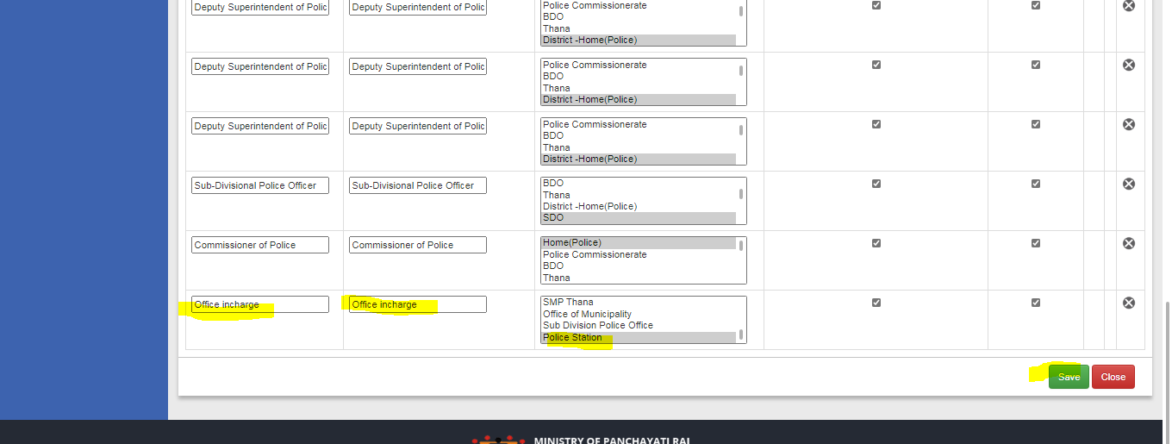

**Functionality 5-** **Generating the LGD SQL script** for the newly created **Home (Police)** department and its hierarchy setup for Service Plus.

After all the procedure do Generate Scripts to upload all the data mapped and created as per hierarchical manner.

Here is the procedure given below to generate scripts.

***\*Note:-Once uploaded no data can be changed. Hence, properly re check the data and generate script***

* **Step 1.**

Select 🡪 **Department**

And Click on **Generate Script**

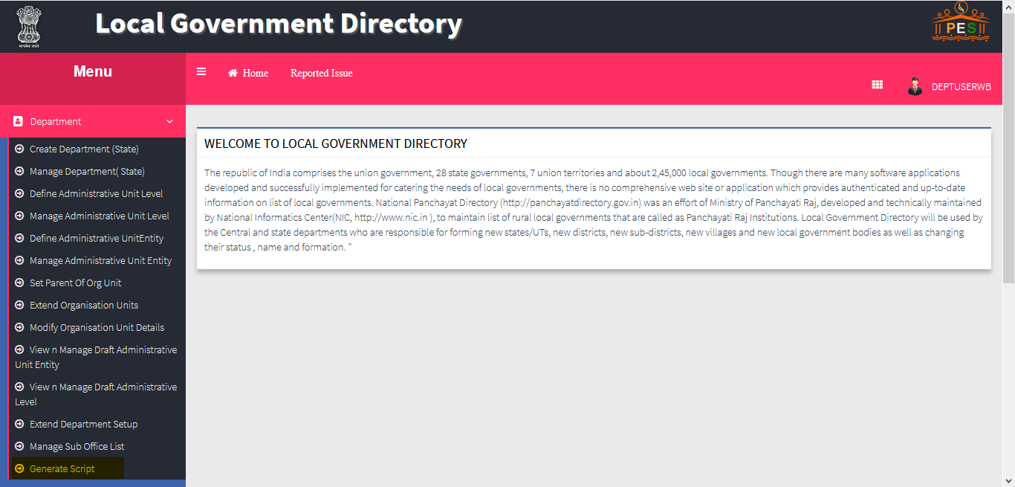

* **Step 2.**

Insert Script

Select **Organization 🡪 Home (Police)**

And Select **Script Generator for** to 🡪 **Organization** and click on button **Generate Insert Script**

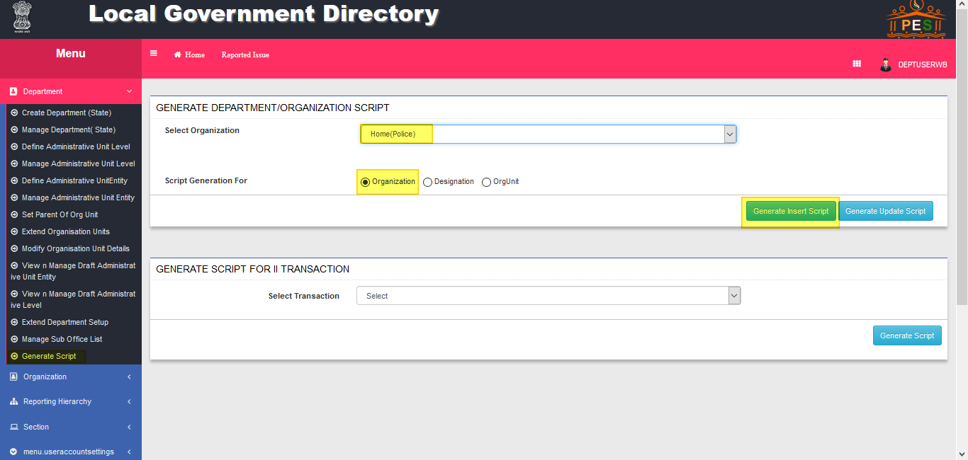

* **Step 3.**

A pop up message will come asking to insert.

Select 🡪 **Yes**

* **Step 4.**

Now do the same for **Update Script.**

* **Step 5.**

Repeat step 1, 2, 3 and 4 for **Designation and OrgUnit.**